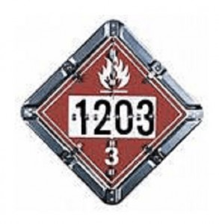
HAZ-MAT OPERATIONS TACTICAL SCENARIO
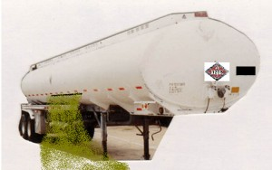

INCIDENT: Your engine company has been alerted to the area of County Road 215 at the Interstate 70 on ramp to investigate a report of single vehicle MVA. The communications officer was unable to get any further information about the incident. Upon your arrival you see an MC-306 low pressure cargo tanker, the tanker has a red and white placard with the number 1203. It appears that the tanker has impacted the jersey wall causing a large tear in the bottom of the tank. You also notice that the tanker’s product is free flowing down the ramp and is beginning to create a large pool on the road way. A victim is noticed lying face down on the ground next to the tanker the victim appears to be unresponsive and saturated in the product.
1. ) What will be your initial tactical consideration for this incident :
2. ) How will you approach the incident scene and where will you place your apparatus:
3.) At the Hazardous Materials Operations Level can your company successfully mitigate this incident and remove the victim from the product.
4.) What resource do you have available to reference the placard and the MC-306 and how long is this resource good for in a hazardous materials incident :
5.) What is the maximum product capacity of the MC-306, What hazards may responders operating at this incident expect and what does the MC stand for :
6.) What will your isolation zones be for a large spill of this product:
7.) What type of PPE is recommended in the mitigation of this product and does this product react with any other product react with any other products. What will be your considerations for decontamination of the victim and responders:
8.) What additional resources will you need to mitigate this Incident:
9.) Is this tanker correctly placarded if not how should it be placarded:

